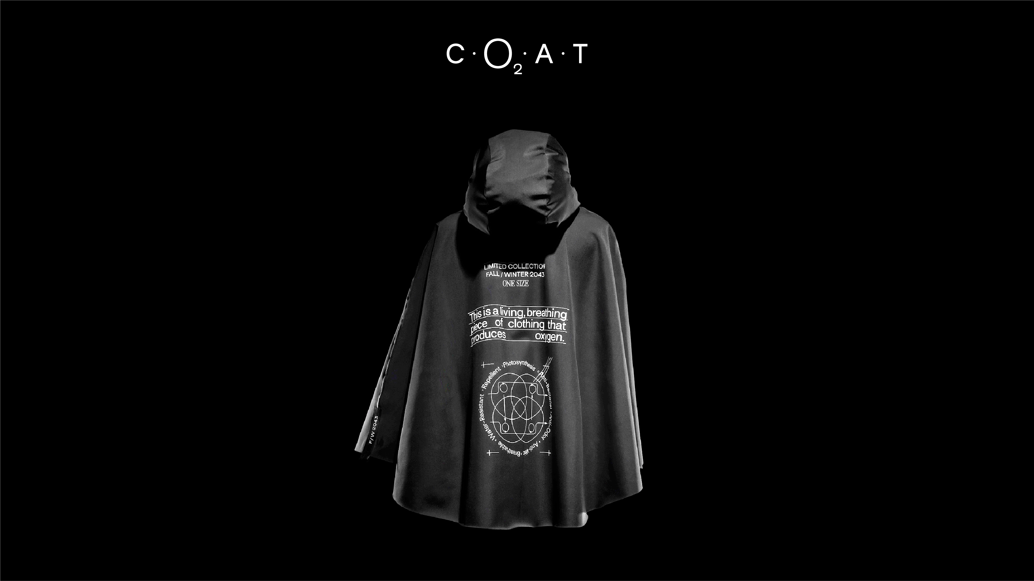
Tomorrow’s garment today

Azgard9 turns a sci-fi fashion dream into reality,
by making a garment that produces O₂

This may look like something from a sci-fi movie, but it is not. It is very real. Denim manufacturer Azgard9 has developed a sustainable garment that produces Oxygen, in what is seen by the brand as the “garment of the future”.
The garment, that is in reality a poncho [CO₂AT], was produced as part of Azgard9’s recent repositioning “Future Before Fashion”, focused on the development of products and solutions with low impact on the environment. Developed in partnership with Post Carbon Lab, in London, the CO₂AT is a living being. Its hoodie is treated with microbial pigmentation, so actually behaving like a plant by using photosynthetic microorganisms – a process by which plants take in carbon dioxide and turn it into glucose and oxygen. Therefore, during its life cycle, it releases oxygen, improving the immediate environment of the wearer, due to its living cells coating. It is life cycle, the poncho neutralizes the impact of its production, improves the immediate environment of the wearer and produces approximately de same amount of O₂ as an oak tree.

A leading Pakistani denim producer, Azgard9 has put in place a highly innovative and challenging fashion project that aspires to realize what the future of fashion might actually look like; with a piece of clothing that is capable of having the same impact on the environment as a plant.

“While brands are thinking about their next collection, we have been thinking about collections of and for the future. In fact, about what garments may look like fifty years from now. So, we actually produced what could be part of every brand’s collection in 2043. We were tired of thinking about how we could change the “Future of Fashion” for the better and decided to actually do something about it.”, explains Ahmed Shaikh, Azgard9’s CEO. That is how this CO₂AT was born: a laboratory piece designed and created to show Azgard9’s retail network how the fashion industry can start having more than a voice in the effort for greater sustainability and to start actually doing something about it.

Innovation is the way. Mainstream sustainability is the destination.
While Azgard9 has materialised an idea from the future, the goal is now to turn it into a mainstream concept. Serving as a wearable manifesto for the fashion world, the living garment is being shared with the retailer’s global network, that goes from large fashion groups like LVMH, to the biggest fast fashion brands like ZARA.

True to the belief that the planet belongs to everyone, Azgard9 wants its idea of sustainability to be accessible to everyone. An idea of Mainstream Sustainability that materializes the motto “Future Before Fashion” has been created to propel people to act now.

“As a 30-year-old business we have produced some of the most incredible denim pieces for the world’s top fashion brands, creating a network of people that have the power to make a change. It is our responsibility to use that in favour of a bigger cause. Being profitable is still a business priority for us. But we want to have a business that is responsible, that looks into the future and knows that sustainability is key if we want to have a future for our company and our planet. We can have a positive impact on the environment and wanted to show our stakeholders that we can help them achieve that. We want to show them what the future of fashion can actually look like, today.”, concludes Ahmed Shaikh.
Website:
www.co2at.life

Links to See:
CO2AT Videocase: www.vimeo.com/555249801
CO2AT Assembling: www.vimeo.com/556128699
Links to Download:
www.azgard9.com/CO2AT/CO2AT_PR.pdf
www.azgard9.com/CO2AT/CO2AT_Videocase.zip
www.azgard9.com/CO2AT/CO2AT_Presskit.zip
Credits:
Client: Azgard9
Agency: This is Pacifica + Stream and Tough Guy
Creative Direction: Filipe Mesquita & Miguel Durão
Strategy: João Ribeiro & Nicolas Grassi
Design: Filipe Mesquita, Pedro Serrão, Pedro Mesquita, Luís Cepa
Project Management: Ana Fernandes
Brand Direction: Bernardo Lago Cruz

Videocase: Vladimiro Leopoldo
Director of Photography: João Castela
Music & Sound Design: Nuno Craveiro
Video Interviews: Ahmed Sheikh (Azgard9 CEO), Dian-Jen Lin (Post Carbon Lab R&D)
London Footage: Louis Hollis
Pakistan Footage: Hassan Bakhtiar Mirza, Yogi Studios
Sound Mix: Guel
3D film: @looooooch.kb
3D render:@looooooch.kb
In Studio Photographer: Nuno Moreira

Creative Direction and Photography: Frederico Martins
Video and Editing: Raul Sousa
Drone Videographers: Óscar Ribeiro & Liliana Pina
Image Assistants: Pedro Sá, João Ferreira
& Marina Rosillo @ Lalaland Studios
Gaffers: STP Audiovisuais
Grooming: Patrícia Lima
Models: Maria Miguel @Central Models & Paulo Spencer @Face Models
Production: Diogo Oliveira @ Lalaland Studios
Retouching: José Paulo Reis @ Lalaland Studios

Photosynthetic R&D: PostCarbonLab (Dian-Jen Lin + Hannes Hulstaert)
CO2AT Production: Toptuxedo (Isaac Gomes, António Costa)
Fabric: LMA (Luís Dias)
Labels and transfers: Heliotextil (Miguel Pacheco, Conceição Teixeira, Ana Bulhosa)

